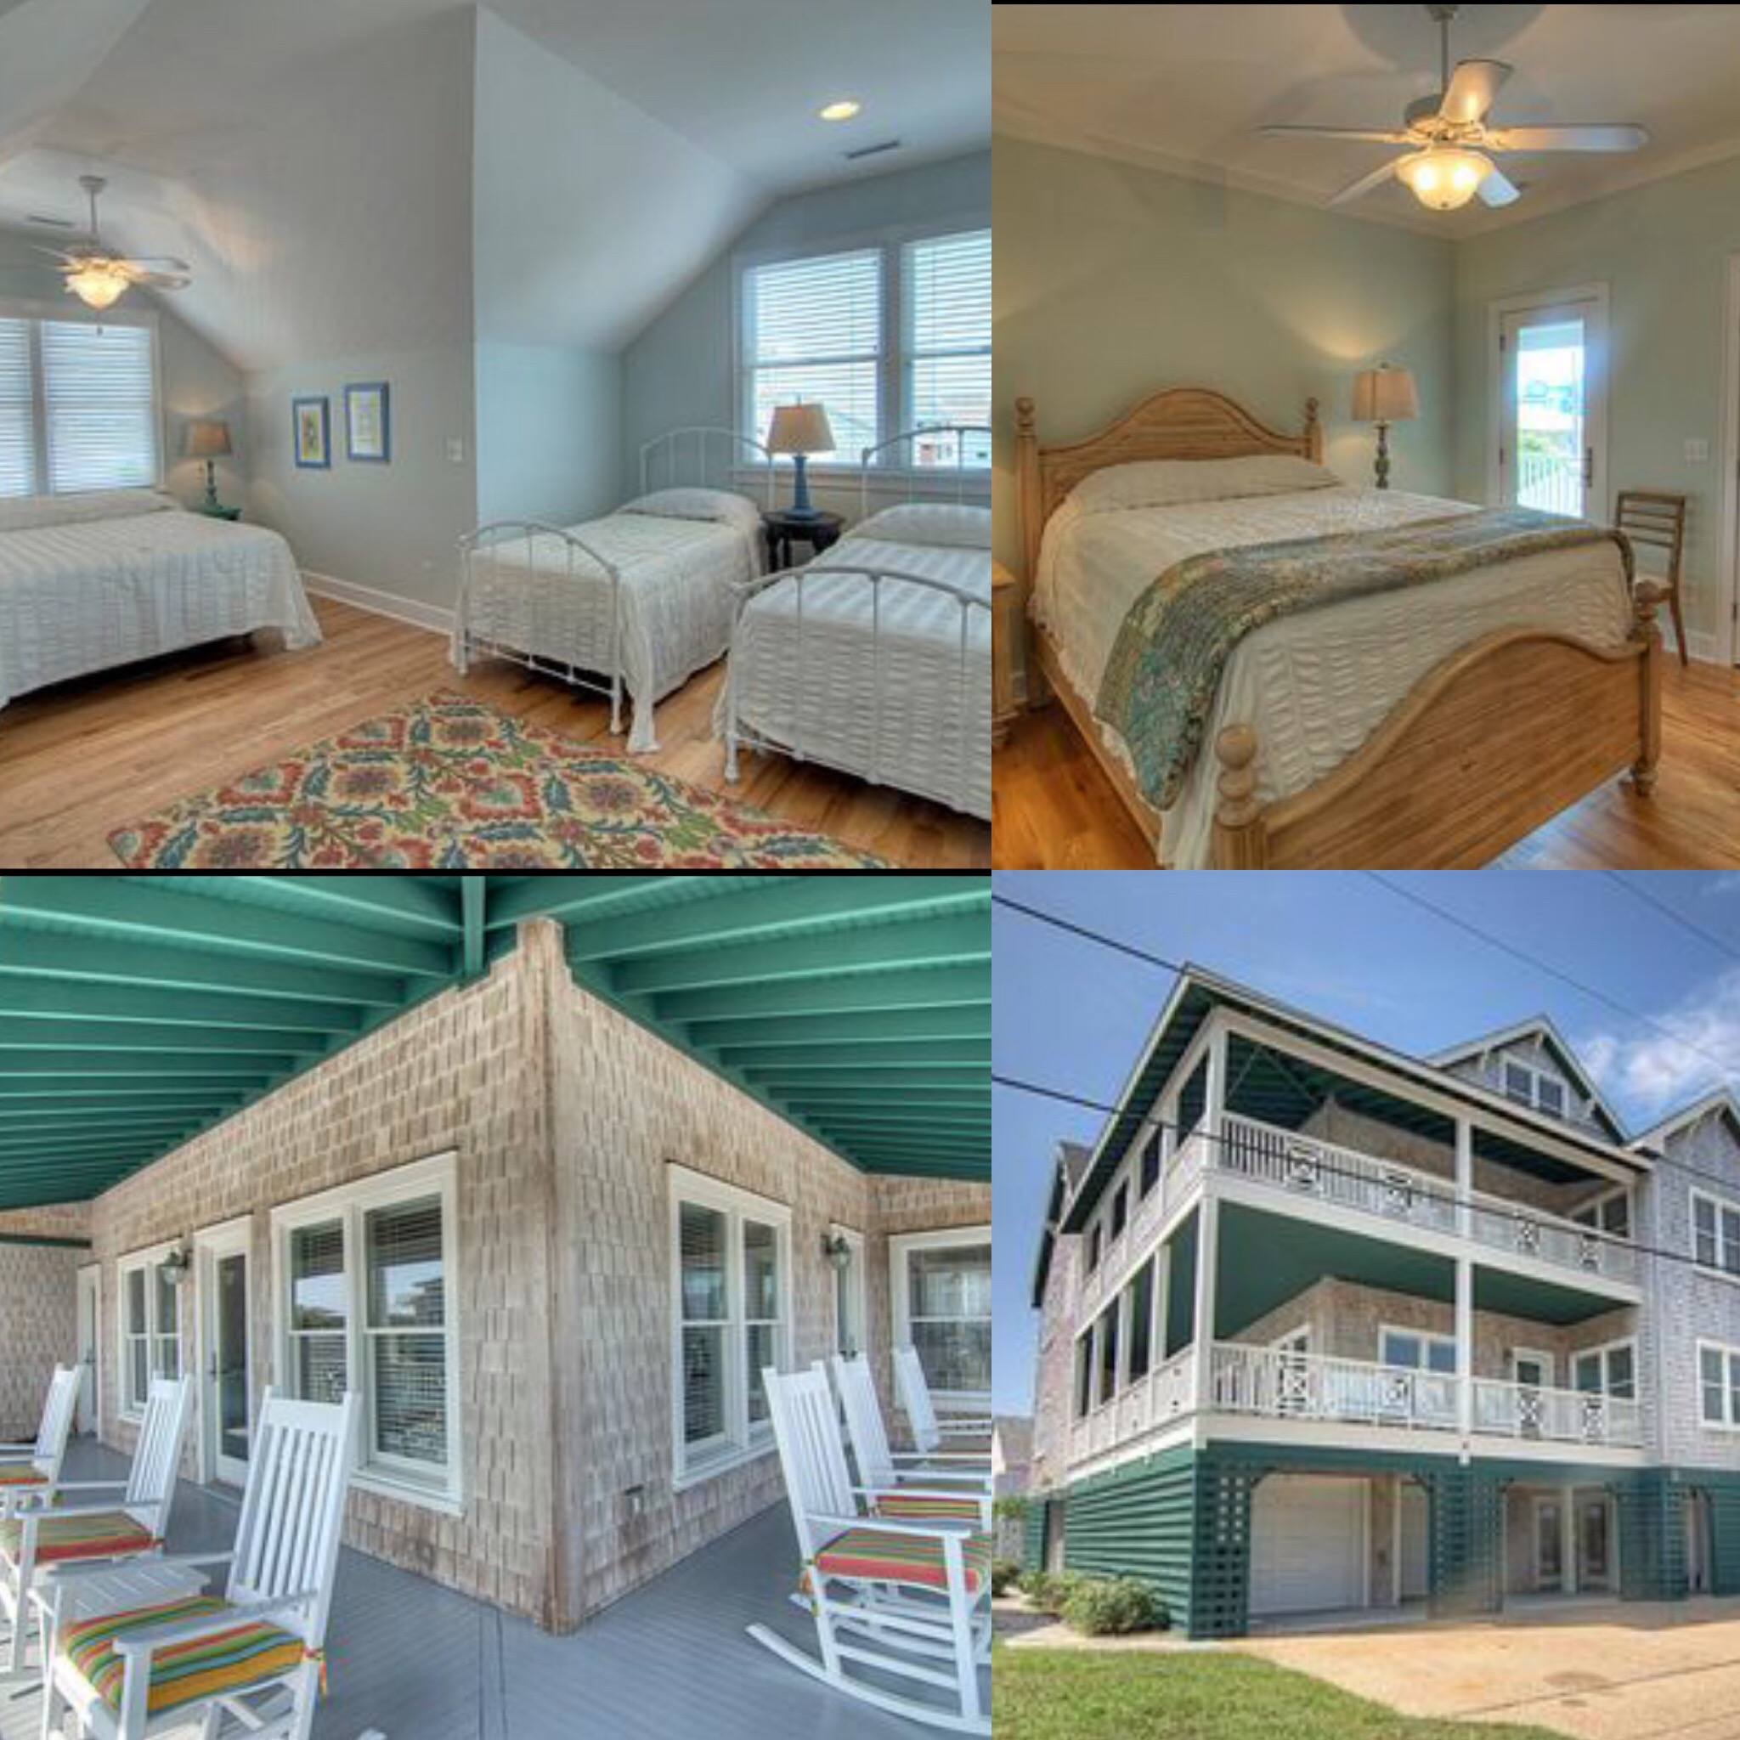  - April 6-8, 2018  NCMA Spring Meeting & retreat, wrightsville beach  Save the date!  NCMA is thrilled to offer a mini-retreat to the midwives and birth workers of NC this spring. We hope you’ll join us for the day or the weekend at this lovely ocean view beach home! We will enjoy yoga, good food and one another’s company as we relax and restore together.  More information will be sent out via email, the webpage, and facebook in the next couple of weeks.
  Affordable 1-2 night stay in this 6 bedroom beach house that sleeps up to 14 people
  ____
  This is a weekend you don’t want to miss!
  ____
  The weekend and meeting are potluck, more details to come about meals and pricing
  ____
  Can’t stay overnight? Join us for the Spring meeting and potluck on Saturday 4/7 12-4p
  ____
  Thank you to Meredith Christie for hosting!
  Yoga and at least one other educational activity will be offered
  The house can be viewed online at https://www.homeaway.com/vacation-rental/p3997472#ratesAnchor

